**Screenshot of Backend server running: -**

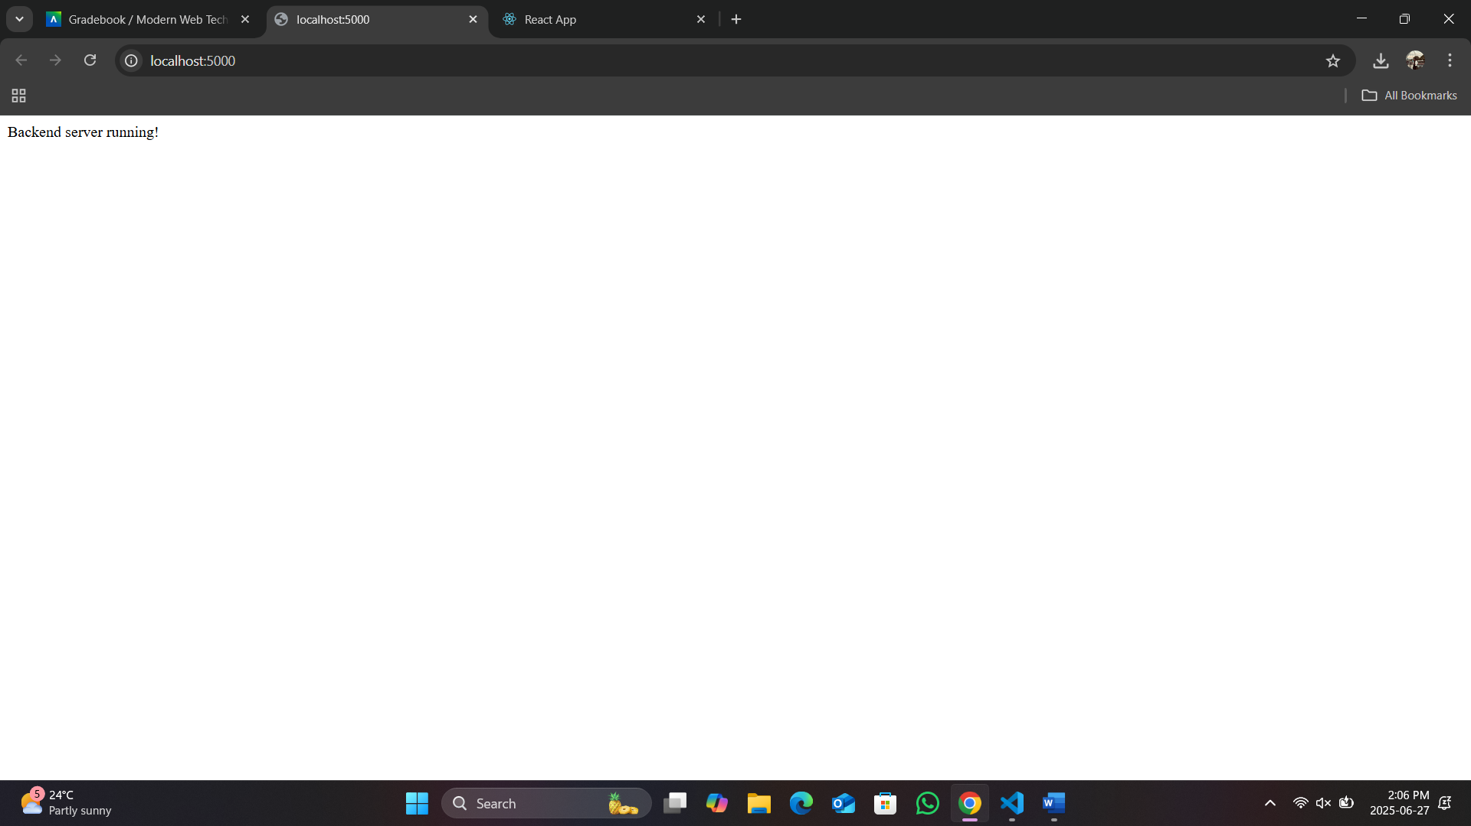

**Screenshot of Home Page React App: -**

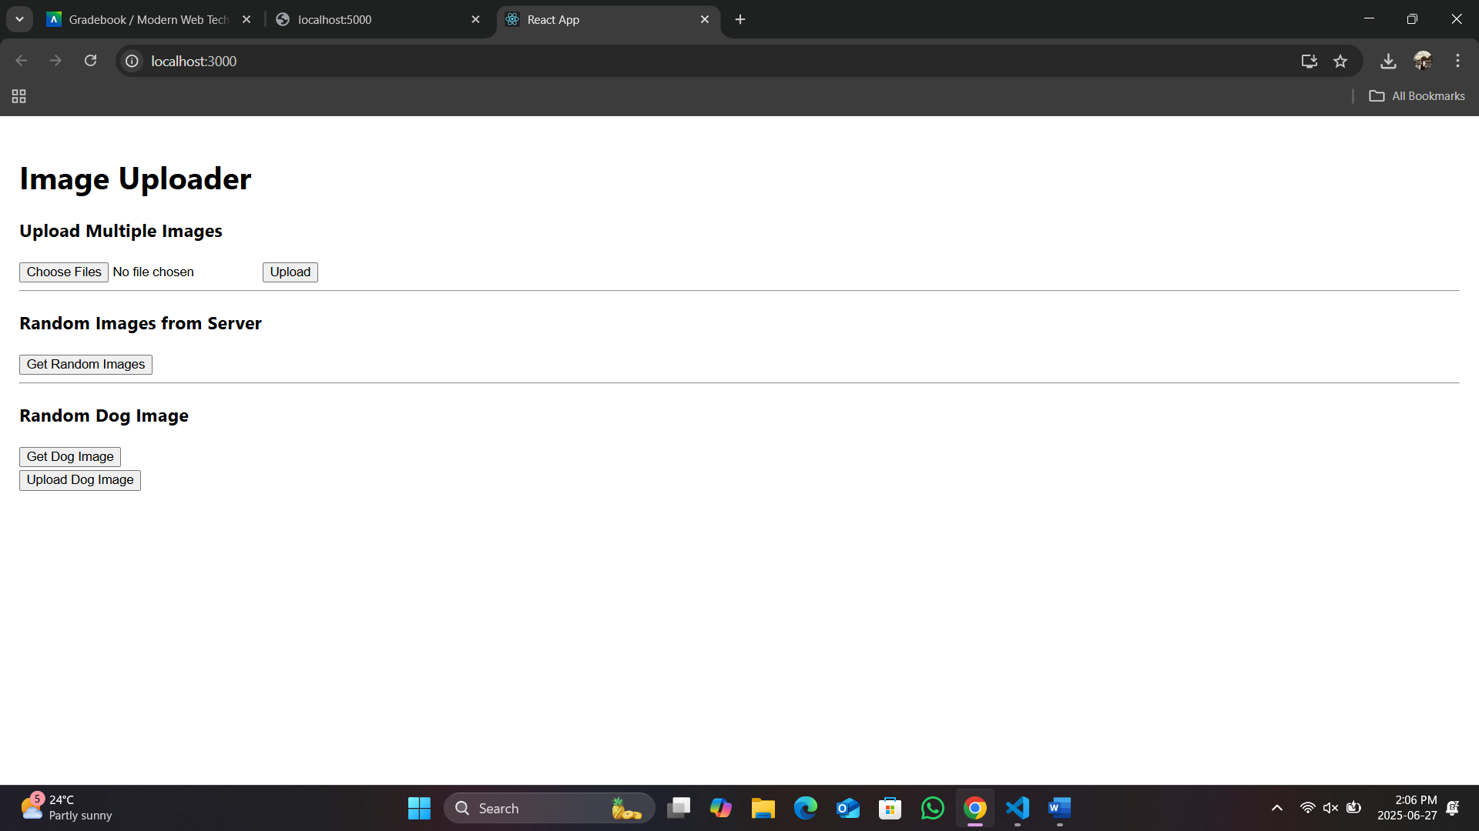

**Screenshot of Image Upload: -**

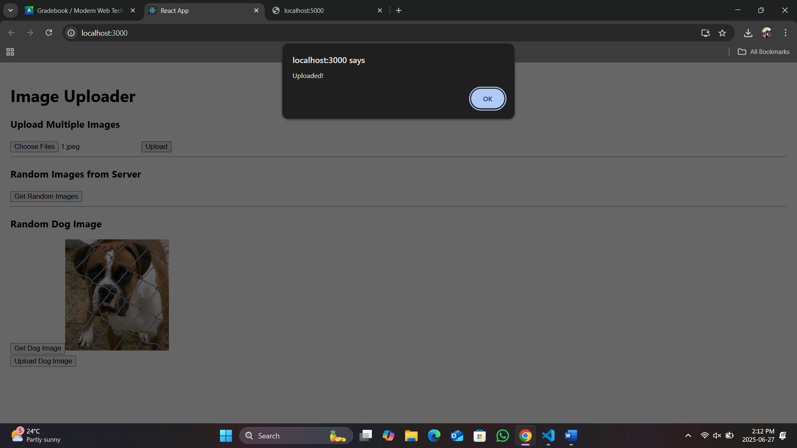

**Screenshot of Random Images from Server: -**

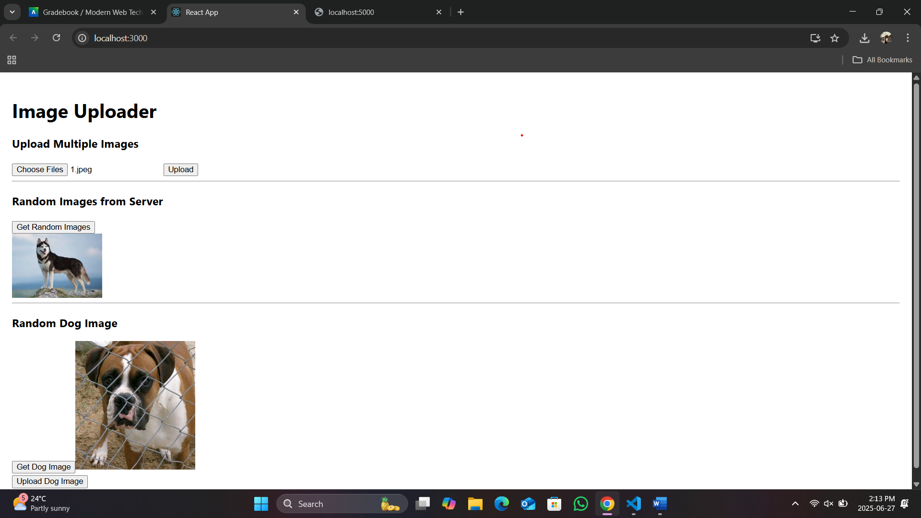

**Screenshot of Get Random Dog Image: -**

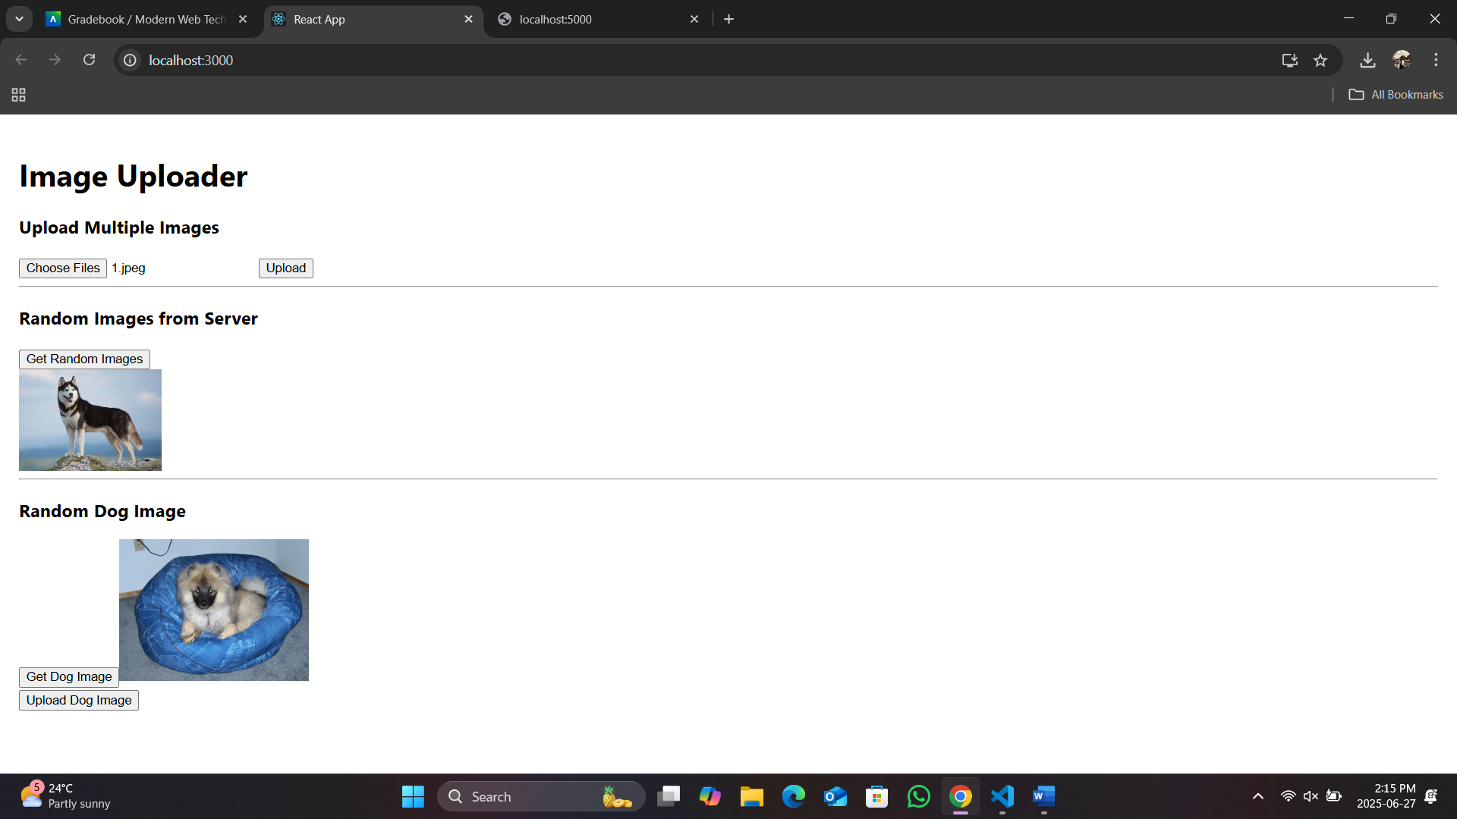

**Screenshot of Upload Random Dog Image: -**

